MMK101 Marketing Fundamentals

Marketing Plan – Marketing Mix Strategy

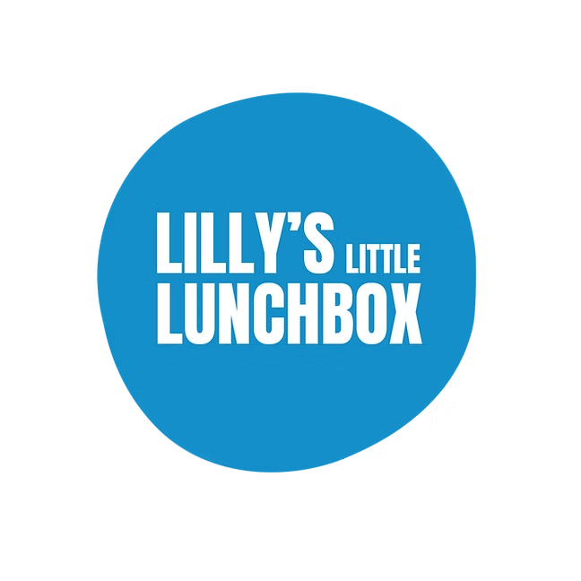
https://www.lillyslittlelunchbox.com/

Trimester 2, 2025

Student Name: Minh Nguyen Khac Ha
Student Number: 225443664
Assignment Word Count: 1427

Please use the checkboxes to indicate all the different ways you used AI in completing this assignment.
Generative AI Uses
- Clarification of marketing concepts | X
- Creative/visuals
- Drafting/writing  - Which sections: 5.3, 5.4 | X
- Editing / re-wording | X
- Reference formatting | X
- Other
  - Describe:
No AI usage.
(Only click this if you do not click any of the other boxes.)

- Referencing Generative Artificial Intelligence (AI) tools (eg. ChatGPT): e.g., as generated by the generative AI program (OpenAI, 2023); According to OpenAI (2023) ChatGPT states that the relationship between ... and ...
- Reference list: OpenAI. (2023). ChatGTP (Mar 14 version) [Large language model]. https:chat.openai.com/chat
In MMK101 Marketing Fundamentals, we use a live case study which addresses a real industry/company problem or opportunity. We will provide the focal company with the top five (5) reports as judged by the MMK101 Marketing Fundamentals Unit Team.
If your assignment is chosen to be provided to the focal organisatio\n, do you give permission?
Yes X No

Table of Contents
Target Market/Consumer Profile, Differentiation Strategy and Positioning Statement 1
5. Marketing Strategy Recommendations 2
5.1. Product Strategy 2
5.2. Pricing Strategy 2
5.3. Distribution and Logistics (placement) Strategy 3
5.4. Integrated Marketing Communications Strategy 3
5.5. Marketing Metrics 4
This section can be presented in a table, but the table content is included in the word count 4
6. Conclusion and Implications 4
Reference List 5

Please do not delete the table of contents.
To update the Table of Contents, right hand click anywhere on the table, click on ‘update field’ and then ‘update entire table’ Please remove these instructions prior to submission.

[Delete this box before submission]
Your Assessment must be formatted as follows:
- Word document format only, A4 size (NO PDF or .pages)
- 12 point, Times New Roman or Arial font
- 1.5 or double spaced (no single spacing)
- Please do not delete the headings as they have been pre-set to develop the table of contents.
- If you use tables, graphs or images, use the following captions (captions are short descriptions of the content of the table, graph, image:
Table 1: Short title of content e.g., Marketing metrics
Table captions should be placed above the table –
Figure 1: Short title of content e.g., Multi-distribution Strategy …..
Figure captions should be placed below the figure/graph/image
All captions should be in numerical order – Figures are for e.g., graphs and charts, images are for logos and pictures. When using information from e.g., the library, you need to include a source directly under the image (should use 9 size font).
e.g.: Source: Australian Bureau of Statistics, 2021.

Target Market/Consumer Profile, Differentiation Strategy and Positioning Statement
Target Market/Consumer profile: This box contains the key points from Assignment 1
My target customer are university student, aged from 18 to 24, living in Brisbane metropolitan areas, sharing rental, and working part time, earning $15,000–$25,000 per year. Time poor, they value taste, health, convenience, and are highly active on social media such as Instagram, YouTube, TikTok.

Differentiation strategy: This box contains the key points from Assignment 1
Lilly’s Little Lunchbox differentiate themselves with healthy product and convenience service. The product is tailored to students, combining nutrition from the five core groups and remain fresh in the fridge for a week due to their special packaging. On the other hand, meals are delivers to customer house, saving time for busy families and student.

Positioning Statement: This box contains the key points from Assignment 1
To university student, who want tasty, healthy, and affordable lunches, Lilly’s Little Lunchbox offers a convenient meal and delivery service that offers you a healthy eating habit designed by dietitian based on the five core food groups and are delivered weekly to save time and reduce daily stress.

5. Marketing Strategy Recommendations

5.1. Product Strategy
The product strategy for Lilly’s Little Lunchboxes should satisfy consumer expectations while supporting management objectives to increase brand recognition and build a strong, health focused brand image. The strategy focuses on adapting Lilly’s Little Lunchboxes to the needs of university students who are time poor, health conscious, budget sensitive. According to the survey, the most important attributes when choosing a lunch are protein content, freshness, tasty and easy to carry, while packaging and heating requirements are less important (Deakin University, 2025). This aligns with research highlighting that university student eating behaviors are influenced by cost, time, and the availability of food option (Deliens et al., 2014).
Figure 1: Student preferences for lunch attributes (MMK101 Lilly’s Little Lunchboxes survey).
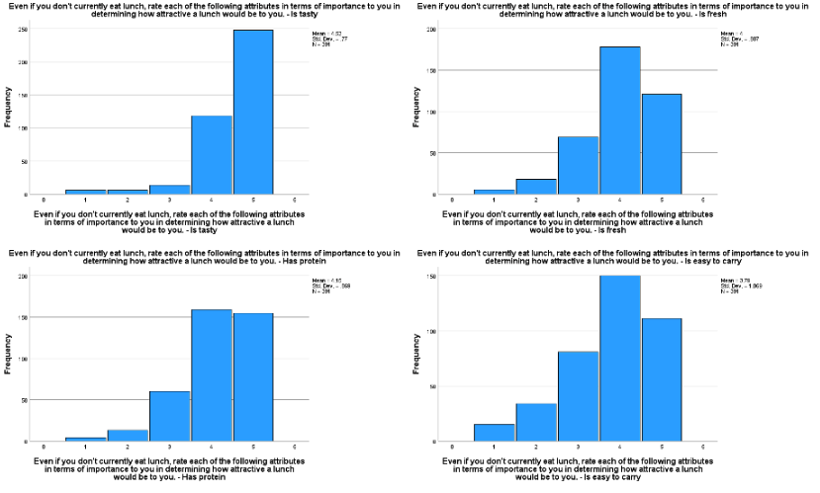 Source: Deakin University, 2025, MMK101 Lilly’s Little Lunchboxes survey results.

Figure 2: Student perceptions of less important lunch attributes (MMK101 Lilly’s Little Lunchboxes survey).
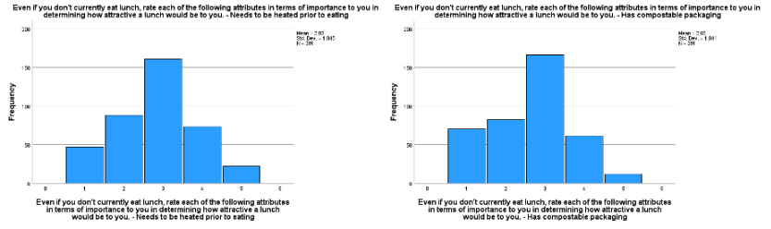Source: Deakin University, 2025, MMK101 Lilly’s Little Lunchboxes survey results.
It is recommended that Lilly’s Little Lunchboxes develop a ready to eat lunchboxes tailored for student, branded as the “Box of Fresh (BOF)”. The BOF would feature smaller, affordable portion designed by dietitians, providing balanced nutrition in portable recyclable packaging that can be consumed easily between classes. This might strengthen Lilly’s Little Lunchboxes differentiation strategy of combining convenience with nutrition, offering student a time saving and a healthier alternative to fast food.

The augmented product includes student discount, subscription bundles, and availability through campus café, ensuring accessibility and relevance to student lifestyles. The product should include an allergen warning label. Research shows that unclear or missing allergen labelling on prepackaged food contributes directly to accidental allergic reactions among consumers (Wang et al.,2025), highlighting the important of this addition.
By using recyclable compostable packaging, Lilly’s Little Lunchboxes supporting SDG 12: Responsible Consumption and Production through waste reduction, while balanced meals advance SDG 3: Good Health and Wellbeing. This alignment strengthens the brand social purpose and appeals to ethically minded customers.

Figure 3: Three levels of product for Lilly’s Little Lunchboxes.
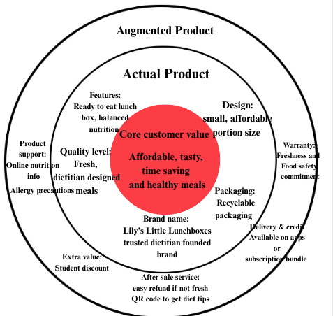

5.2. Pricing Strategy
Currently, Lilly’s Little Lunchboxes is positioned as a premium product, selling at $100 for five meals ($20 per meal) (Lilly's Little Lunchboxes, 2025). While this reflects the health focused brand image, it is unattractive to university student who earn an average of $16,310 (Wallis & Blackburn, 2021). At this point, students prefer cheaper alternative such as campus café or fast food. Additionally, a KFC meal costing around $10 (KFC, 2025).
It is recommended that Lilly’s Little Lunchboxes adopt a penetration and value-based pricing strategy to improve affordability, encourage trial. A student friendly price of $14.99 per meal or $69.99 for bundle of five meals, making Lilly’s Little Lunchboxes more competitive while reflecting its health and convenience value. This also reflects a value-based pricing approach, where prices are set according to the value delivered and perceived by customer (Hinterhuber, 2008). Students show enthusiasm for lunch that caters to their preference and restriction (Deakin University, 2025).
Figure 4: Student interest in lunch options that cater to dietary preferences or restrictions (MMK101 Lilly’s Little Lunchboxes survey).
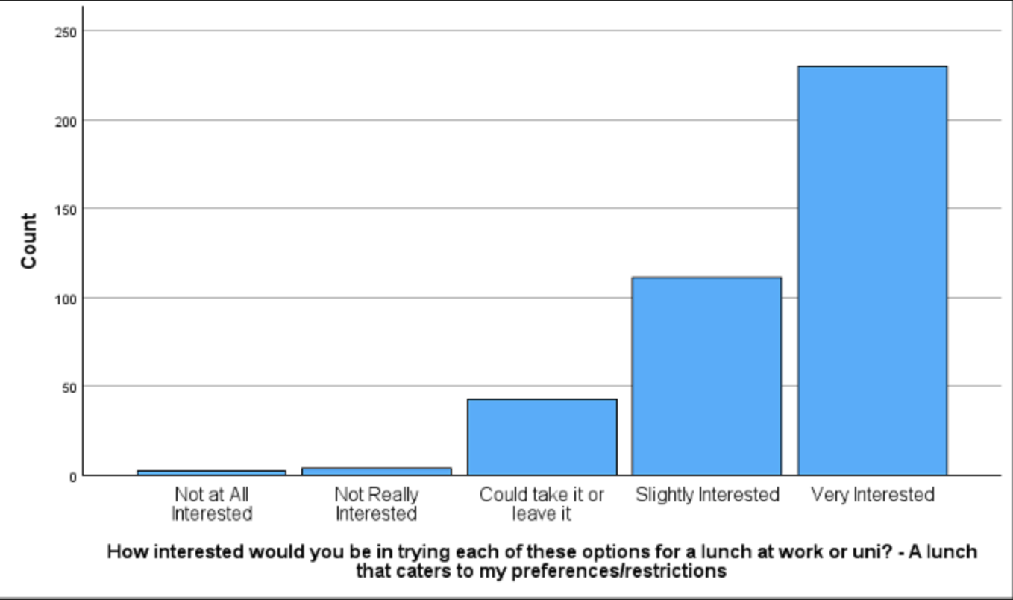 Source: Deakin University, 2025, MMK101 Lilly’s Little Lunchboxes survey results.
To further attract student, Lilly’s Little Lunchbox should apply bundle and discount pricing, including a 10% discount with student ID or a 15% discount for subscription bundle. Customers are more likely to purchase a discount bundle because they believe financial savings and value (Hahnchen & Baumgartner, 2020). First time buyer could receive a coupon or discount for future purchases to encourage loyalty. Studies show that discount can have positive effects on consumer perceptions (Darke & Dahl, 2003; Inman et al., 1997; Urbany et al., 1988; as cited in Darke & Chung, 2005)
Together, these strategies will increase brand recognition by boosting trial and campus visibility, while emphasize brand image as an affordable health focus meal brand.

5.3. Distribution and Logistics (placement) Strategy
Presently, Lilly’s Little Lunchboxes delivers products directly to consumers through their website. While convenient, this limited brand recognition, physical visibility, and customer trial. The number of student who purchase their lunch through online or direct from manufacturers are very low (Deakin University, 2025). To improve accessibility, the brand should expand beyond their website by introducing multiple distribution point, such as campus café, retail supermarket, and online delivery platforms. Using multiple channels helps meet customer needs by using strengths and reducing weaknesses of each channel (Zhang et al., 2010).
Figure 5: Student lunch purchase preferences – Online or direct from manufacturers (MMK101 Lilly’s Little Lunchboxes survey).
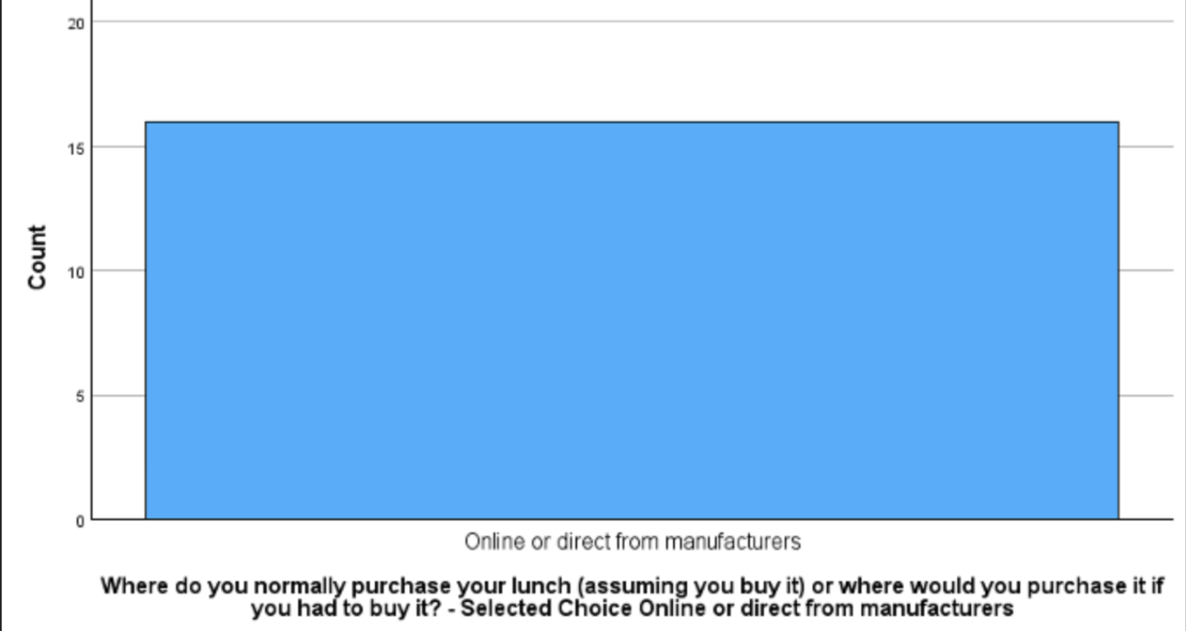 Source: Deakin University, 2025, MMK101 Lilly’s Little Lunchboxes survey results.

Figure 6: Multichannel distribution network for Lilly’s Little Lunchboxes.
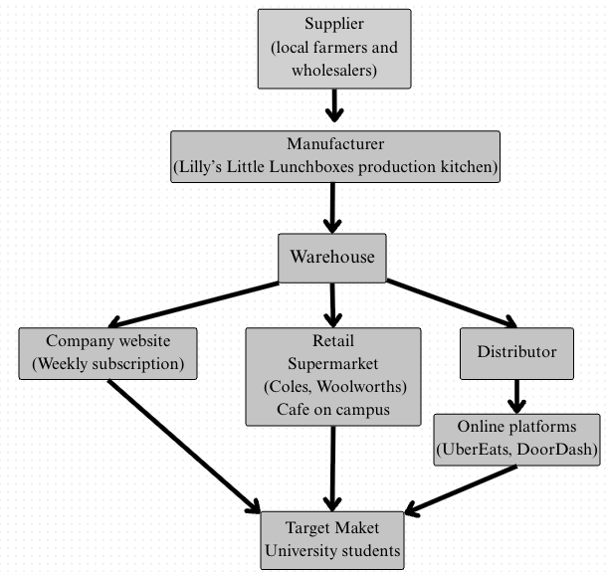
According to figure 6, the distribution flow begins with suppliers providing fresh ingredients to the production kitchen, before moving to a central warehouse, which functions as the hub for logistics and inventory management. The warehouse should be located in suburban industrial zones such as Eagle Farm or Acacia Ridge balances lower rental costs, while near to major highways for efficient transport. From the warehouse, products are distributed through several channels. The website remains the core platform, offering subscriptions and home delivery. Partnerships with UberEeats and DoorDash will enhance convenience by collecting from nearby supermarket or café where they are already stocked, reducing delivery time and costs. To supply retailers and campus café, meals will be transport in refrigerated vans on scheduled timetables to ensure freshness and compliance food safety law. Supermarket will require large deliveries several times per week, while café will be supplied more frequently in smaller quantities due to limited storage space. Placement in these location provides physical visibility and encourage trial, align with the survey that university most often purchase their lunch from large supermarkets and on campus café (Deakin University, 2025).
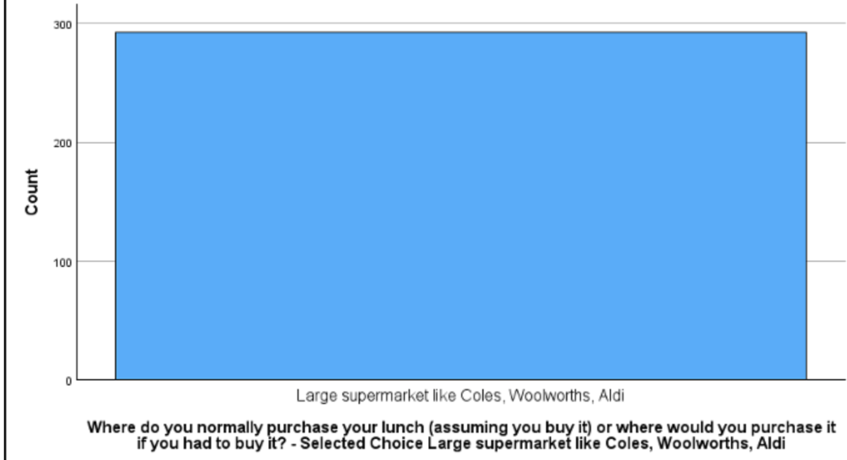
Figure 7: Student lunch purchase preferences – Large supermarkets (Coles, Woolworths, Aldi) (MMK101 Lilly’s Little Lunchboxes survey).

Source: Deakin University, 2025, MMK101 Lilly’s Little Lunchboxes survey results.
Figure 8: Student lunch purchase preferences – Campus cafés (MMK101 Lilly’s Little Lunchboxes survey). 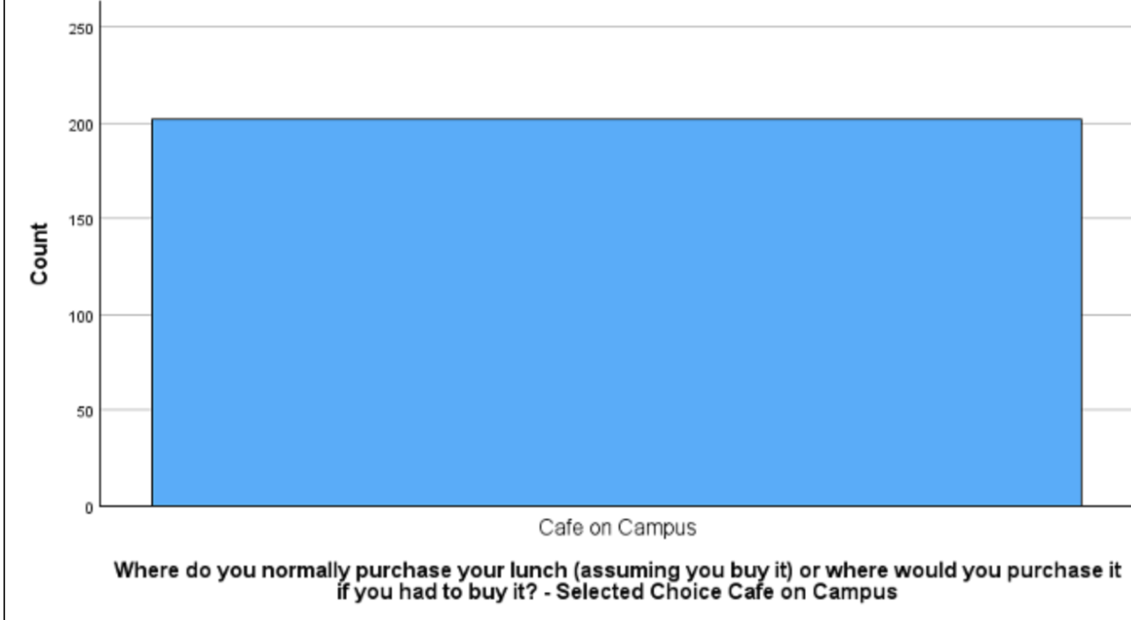Source: Deakin University, 2025, MMK101 Lilly’s Little Lunchboxes survey results.
This multichannel strategy strengthens Lilly’s Little Lunchboxes visibility and accessibility, while expand brand awareness and optimize in store presence.

5.4. Integrated Marketing Communications Strategy
Lily’s Little Lunchboxes currently promotes through Instagram, TikTok, YouTube and Facebook with tips, menu updates, and short videos showing their healthy dietitian designed lunchboxes. This approach is effective, as the survey show many students are active on social media particularly TikTok, YouTube and Instagram (Deakin University, 2025).

Figure 9: Student use of Instagram, TikTok, and YouTube (Deakin University, 2025, MMK101 student survey).
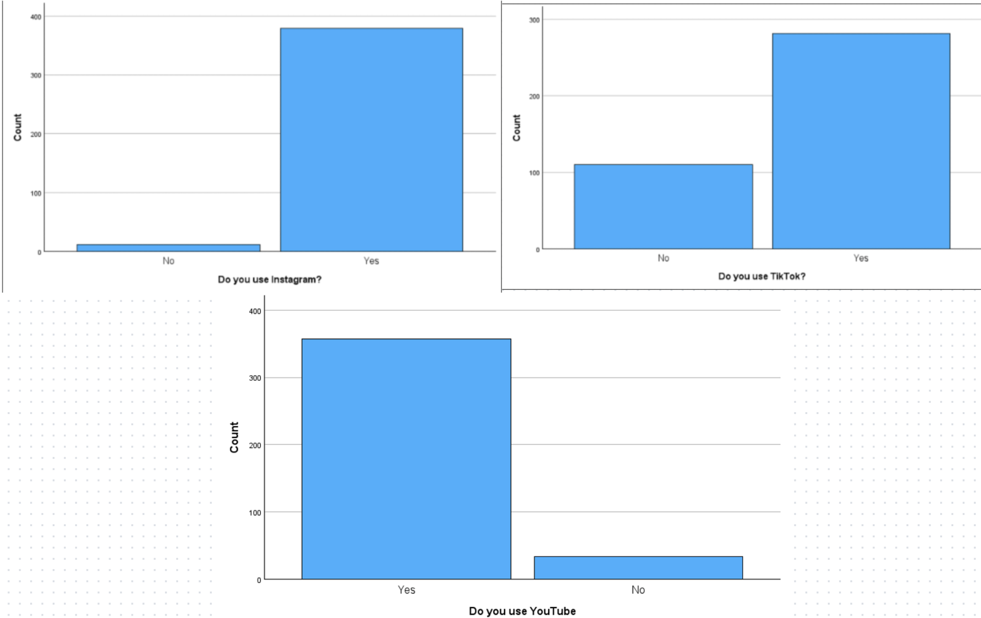Source: Deakin University, 2025, MMK101 Lilly’s Little Lunchboxes survey results.
However, their promotion is not effective to university student, because the content mostly information, and lacks interactive and entertaining elements. Research show social media are critical for consumer engagement and purchasing decisions (Barari et al., 2025). Beside that over 40% of Gen Z and Millennials have purchase through social media in the past three months (HubSpot,2025). To leverage the potential of social media, Lilly’s Little Lunchboxes should adopt an integrated marketing communications (IMC) that combines social media, on campus events. In addition, collaborating with student lifestyle influencer to show case the company as a healthy, affordable meals provider.
Secondly, pop up tasting booths at campus events with free sampling and new customer discount, are highly effective in encouraging trial and repeat purchase. Student value taste and protein content when choosing lunch (Deakin University, 2025), and trials can influence the purchase decisions by building the consideration set (Loupiac & Le Nagard, 2024).
Finally, a digital “Build your BOF” campaign can strengthen engagement by allowing students to vote for preferred proteins, fruits and snack through polls on social media, showing Lilly’s Little Lunchboxes flexibility and listening to customers. Customer engagement on social media is mainly influenced by satisfaction, positive, emotions, and trust (de Oliveira Santini et al., 2020), making this campaign effective in building brand loyalty and awareness.

5.5. Marketing Metrics
Figure 10: Marketing Metrics.
Marketing Mix | Metric | What it measures
Product | Customer satisfaction rate (%)  Repeat purchase rate (%)  Product reviews (1-5 scale) | Measures how well the BOF meet the student expectations, and the number of repeat purchase.
Price | Discount redemption rate (%)  Order rate (count) | Measures effective of student discounts and bundle selling.
Place | Number of distribution point (number of outlets)  Number of sales through channels | Measures accessibility, and performance of each distribution channel.
Promotion | Social media interaction (likes / shares /comments)  Number of new customers (count/week)  BOF Campaign participation (votes) | Measures brand awareness, engagement, interactivity, and effectiveness in attract new customers.

6. Conclusion and Implications
The research from assessment 1 and 2 illustrate that university student is a viable target segment for Lilly’s Little Lunchboxes. Assessment 1 showed student segment is time poor, budget conscious, health aware, and digital user. While Assessment 2 built up a marketing plan with the 4P’s based on the target segment, by recommending product strategy meals design for university student, Box of Fresh (BOF) with customization and a recyclable, portable and recyclable packaging. Penetration and value-based pricing through discounts, bundle pricing and coupon for future purchases. Multiple distribution channels including company website, retail supermarket, on campus café, and online delivery. Promotion through IMC program by combining collaborating with social influencers, on campus tasting booths, and “Build Your BOF” campaign. However, even if it is the perfect plan, challenges still exist, including channel conflict, competition from fast food and other ready meal brands.
I believe that my recommendations are effective in building brand recognition and emphasize Lilly’s Little Lunchboxes image as a healthy, affordable option, with strong product strategy, IMC program, multi distribution channels inevitably lead to an increase in sales figures, market penetration, and share.

Reference List
Barari, M. M., Eisend, M., & Jain, S. P. (2025). A meta-analysis of the effectiveness of social media influencers: Mechanisms and moderation. Journal of the Academy of Marketing Science: Official Publication of the Academy of Marketing Science, 1–21. https://doi.org/10.1007/s11747-025-01107-3
Deakin University. (2025). MMK101 Lilly’s Little Lunchboxes survey. Faculty of Business and Law, Deakin University.
de Oliveira Santini, F., Ladeira, W. J., Pinto, D. C., Herter, M. M., Sampaio, C. H., & Babin, B. J. (2020). Customer engagement in social media: a framework and meta-analysis. Journal of the Academy of Marketing Science: Official Publication of the Academy of Marketing Science, 48(6), 1211–1228. https://doi.org/10.1007/s11747-020-00731-5
Deliens, T., Clarys, P., De Bourdeaudhuij, I., & Deforche, B. (2014). Determinants of eating behaviour in university students: a qualitative study using focus group discussions. BMC Public Health, 14(1), 1–22. https://doi.org/10.1186/1471-2458-14-53
Hinterhuber, A. (2008). Customer value-based pricing strategies: Why companies resist. Journal of Business Strategy, 29(4), 41–50. https://doi.org/10.1108/02756660810887079
Hahnchen, A., & Baumgartner, B. (2020). The Impact of Price Bundling on the Evaluation of Bundled Products: Does It Matter How You Frame It? Schmalenbach Business Review, 72(1), 39–63. https://doi.org/10.1007/s41464-020-00082-2
HubSpot. (2025). 2025 global social media trends report. HubSpot. https://www.hubspot.com/state-of-marketing

KFC. (2025). Menu. KFC Australia. https://www.kfc.com.au/menu
Lilly's Little Lunchboxes. (2025). Blocked. Lillyslittlelunchbox.com.au. https://lillyslittlelunchbox.com.au/shop
Loupiac, P., & Le Nagard, E. (2024). Understanding the role of physical trial for good shopping decisions. RAUSP Management Journal, 59(3), 312–328. https://doi.org/10.1108/RAUSP-12-2023-0245
Wang, J., Liu, W., Gao, J., Wang, Z., Min, F., Lu, J., Li, X., Wu, Y., & Chen, H. (2025). Assessment of Knowledge, Attitude, and Practice (KAP) Regarding Food Allergen Labeling
Among Allergic Population in Jiangxi Province, China. Journal of Food Science (John Wiley & Sons, Inc.), 90(7), 1–12. https://doi.org/10.1111/1750-3841.70411
Wallis, S., & Blackburn, T. (2021, June 22). Student finance statistics. Finder.com.au; finder. https://www.finder.com.au/insights/student-finances-statistics?utm_source=chatgpt.com
Zhang, J., Farris, P. W., Irvin, J. W., Kushwaha, T., Steenburgh, T. J., & Weitz, B. A. (2010). Crafting Integrated Multichannel Retailing Strategies. Journal of Interactive Marketing, 24(2), 168–180. https://doi.org/10.1016/j.intmar.2010.02.002

